[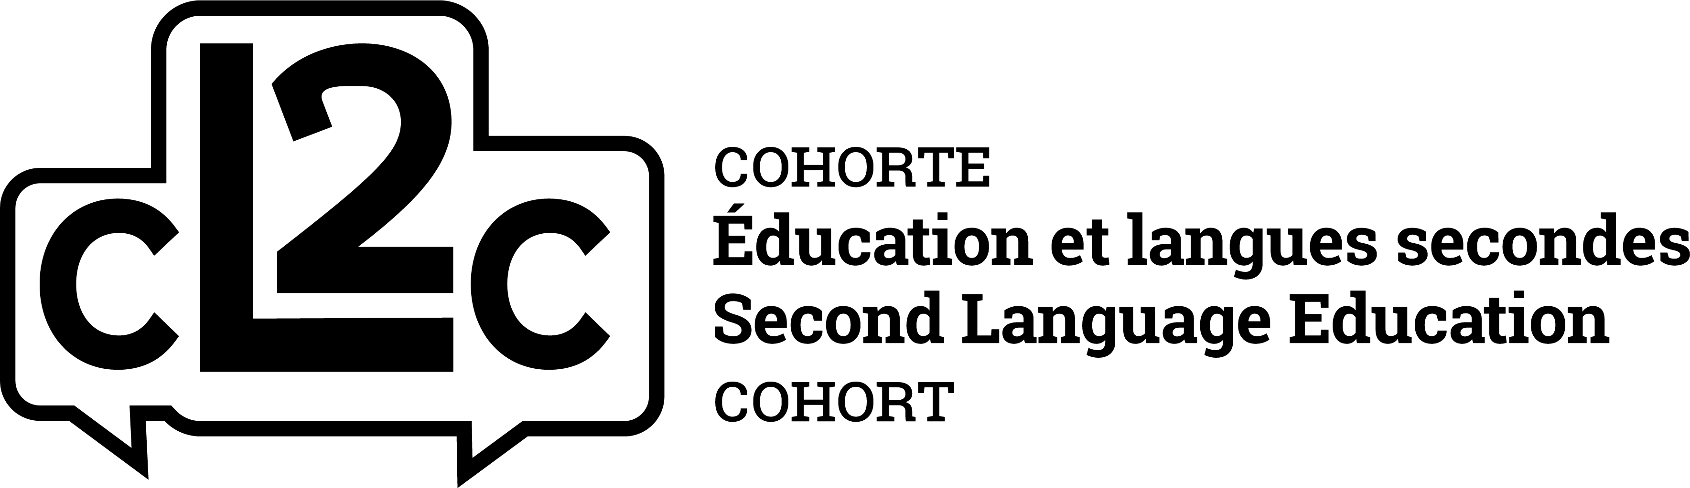](http://www.cl2cuottawa.ca/en/)

***Every teacher is a language teacher / Chaque enseignant enseigne la langue***

The Second Language Education Cohort (cL2c) is off to a great start this year, with two exciting initiatives up and running – and many others still to come!

**Plurilingual Reading Groups**: Our first session on October 9th with pre-schoolers from the Garderie Bernadette (the daycare at the University of Ottawa) was a great success! Six Year 1 students graciously offered their time and energy to read stories and sing songs to the little ones, in both English and French! We are always open to new participants from all cohorts – so sign up today! **Sessions take place on Tuesday (Year 1s) and Thursday (Year 2s) mornings from 10:30-11:15am.** Please fill out the following Doodle polls to indicate your availability (Year 1: <https://doodle.com/poll/td4q9un69nvupgd9>; Year 2:  <https://doodle.com/poll/kec9uchquczmtxuw>). Please email if you have any questions! ([cL2c@uottawa.ca](mailto:cL2c@uottawa.ca))

**PED3150 Cohort PLCs** : On October 5th, we offered a workshop entitled *Every teacher is a language teacher* during the Year 1 Cohort PLC event. We were thrilled that so many of you engaged in contemplating this topic and its relevance to your practice. Many useful strategies and activities were shared! We are excited to offer a wide variety of workshops on this same theme during the cL2c PLC workshops scheduled for January 31st 2019. Stay tuned for more information to come on specific topics and themes!

Please visit our website ([www.cL2cuottawa.ca](http://www.cL2cuottawa.ca)) and follow us on Twitter (@cL2cohort) to keep updated on new resources and all activities throughout the term!